HEAD

What is HEAD in Version Control?
# Source: AI Source: Provided by: [Data Path: Persons Table -> ID Column: 1, Name_En Column: Motasem Essam] -> From: [ChatGPT] on [2/15/2026]
In Git, HEAD is a special pointer that always points to the current commit you are working on. Think of it as “where you are right now in the project history.”

Key points about HEAD
# Source: AI Source: Provided by: [Data Path: Persons Table -> ID Column: 1, Name_En Column: Motasem Essam] -> From: [ChatGPT] on [2/15/2026]
- Points to a commit
  - Usually points to the latest commit on the current branch.
  - When you make a new commit, HEAD moves forward to the new commit.
- Tracks your current branch
  - HEAD points to the branch name, which in turn points to the latest commit.
  - Example: If you’re on main, HEAD → main → latest commit on main.
- Can move
  - When you checkout another branch or commit, HEAD moves to point to that new location.
  - If you checkout a specific commit (not a branch), you’re in a detached HEAD state.

Example
# Source: AI Source: Provided by: [Data Path: Persons Table -> ID Column: 1, Name_En Column: Motasem Essam] -> From: [ChatGPT] on [2/15/2026]
Suppose your commit history looks like this:
C1 → C2 → C3 (branch: main)
- Current branch = main
- HEAD → main → C3
- If you make a new commit C4:
  - HEAD moves to C4
  - Branch main now points to C4

Detached HEAD
# Source: AI Source: Provided by: [Data Path: Persons Table -> ID Column: 1, Name_En Column: Motasem Essam] -> From: [ChatGPT] on [2/15/2026]
- If you checkout a commit directly:
git checkout C2
- HEAD points directly to C2, not a branch.
- Any new commits here are not attached to a branch unless you create one.

Quick analogy
# Source: AI Source: Provided by: [Data Path: Persons Table -> ID Column: 1, Name_En Column: Motasem Essam] -> From: [ChatGPT] on [2/15/2026]
- HEAD = the bookmark of “where you are currently working” in Git history
- Branch = a name for a line of commits
- Commit = a snapshot of files

Memory Trick
# Source: AI Source: Provided by: [Data Path: Persons Table -> ID Column: 1, Name_En Column: Motasem Essam] -> From: [ChatGPT] on [2/15/2026]
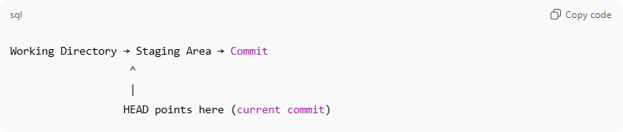
Working Directory → Staging Area → Commit
^
|
HEAD points here (current commit)

